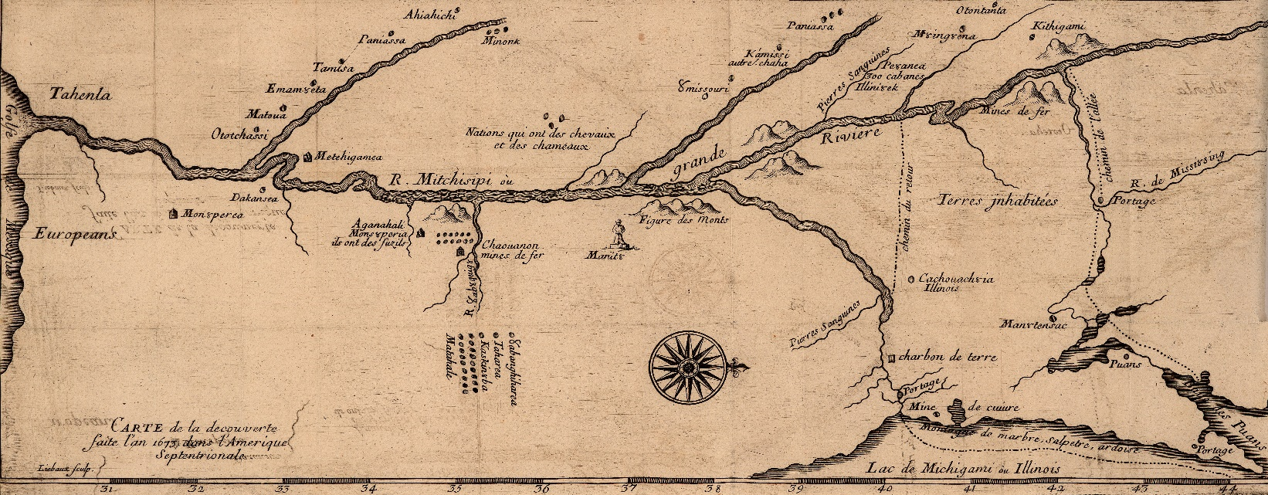

**Home Vita Publications Public Talks Consulting & Media Contact**

**Publications**

**Books**

[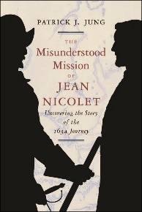](https://shop.wisconsinhistory.org/the-misunderstood-mission-of-jean-nicolet-uncovering-the-story-of-the-1634-journey-3)

[*The Misunderstood Mission of Jean Nicolet: Uncovering the Story of the 1634 Journey*](https://shop.wisconsinhistory.org/the-misunderstood-mission-of-jean-nicolet-uncovering-the-story-of-the-1634-journey-3).

Wisconsin Historical Press, 2018.

[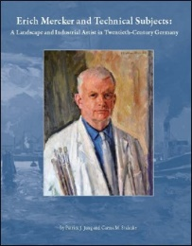](https://commerce.cashnet.com/cashnetg/selfserve/EditItem.aspx?PC=GM-630B1010+&ItemCount=12)

[*Erich Mercker and Technical Subjects: A Landscape and Industrial Painter in Twentieth Century Germany*](https://www.msoe.edu/grohmann-museum/merchandise/)*.* MSOE Press, 2014.

[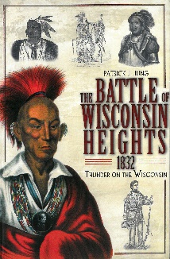](https://www.arcadiapublishing.com/Products/9781609490522)

[*The Battle of Wisconsin Heights, 1832: Thunder on the Wisconsin*](https://www.arcadiapublishing.com/Products/9781609490522). History Press-Arcadia, 2011.

[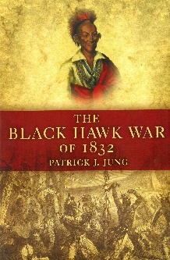](https://www.oupress.com/books/9782912/the-black-hawk-war-of-1832)

[*The Black Hawk War of 1832*](https://www.oupress.com/books/9782912/the-black-hawk-war-of-1832). University of Oklahoma Press, 2007.

**Articles & Essays**

“[American Indian Resistance to Settler Colonialism in the Western Great Lakes and Upper Mississippi Valley, 1815-1832.” *Annals of Iowa* 81 (Winter 2022): 3-44](https://www.academia.edu/70473981/American_Indian_Resistance_to_Settler_Colonialism_in_the_Western_Great_Lakes_and_Upper_Mississippi_Valley_1815_1832).

[“Quantifying Hitler’s Salon: A Statistical Analysis of Subjects at the Great German Art Exhibition, 1937-1944.” *Humanities Bulletin* 4 (2021): 147-167](https://www.journals.lapub.co.uk/index.php/HB/article/view/1984).

[“Iowa Without Borders: Iowa History from European Contact to Statehood.” *Annals of Iowa* 80 (Fall 2021): 365-371.](https://www.academia.edu/57192082/Iowa_without_Borders_Iowa_History_from_European_Contact_to_Statehood)

“‘[The Path to Glory is Rough’: The Causes and Course of the Black Hawk War, 1804-1832.” In Dissolving Myths and Legends: Rivalries, Allies, Histories & Cultures that Shaped the Black Hawk War: Papers from the First Annual History Symposium, November 2, 2019. Sheboygan, Wis.: Sheboygan County Historical Research Center, 2020](https://www.academia.edu/43557085/_The_Path_to_Glory_is_Rough_The_Causes_and_Course_of_the_Black_Hawk_War_1804_1832).

[“The Misunderstood Mission of Jean Nicolet: Uncovering the Story of the 1634 Journey.” *Wisconsin Magazine of History* 102 (Winter 2018): 50-53.](https://www.academia.edu/38615234/The_Misunderstood_Mission_of_Jean_Nicolet_Uncovering_the_Story_of_the_1634_Journey)

“[German Art and Artists in the Grohmann Museum.” *Google Arts and Culture*, 2018](https://artsandculture.google.com/exhibit/JQKShBIqFFx1KQ).

“[The Grohmann Museum Collection at the Milwaukee School of Engineering: An Overview.” *H-Net*, 2017](https://networks.h-net.org/node/25767/discussions/639663/grohmann-museum-collection-milwaukee-school-engineering-overview).

“[The Scope of Early Twentieth-Century German Industrial Art: Works in the Grohmann Museum of Art.” *H-Net*, 2017](https://networks.h-net.org/node/25767/discussions/245120/scope-early-twentieth-century-german-industrial-art-works-grohmann).

“[Lonely Sentinel: A Military History of Fort Madison, 1808-1813.” *Annals of Iowa* 75 (Summer 2016): 201-233](https://www.academia.edu/37660440/_Lonely_Sentinel_A_Military_History_of_Fort_Madison_1808_1813_).

“[Toward the Black Hawk War: The Sauk and Fox Indians and the War of 1812.” *Michigan Historical Review* 38 (Spring 2012): 27-52](https://www.academia.edu/37662359/_Toward_the_Black_Hawk_War_The_Sauk_and_Fox_Indians_and_the_War_of_1812_).

“[Erich Mercker and ‘Technical Subjects’: Industrial Painting in the Eras of Weimar and Nazi Germany.” *Journal of the Society for Industrial Archeology* 34 (2008): 149-164](https://www.academia.edu/37660419/_Erich_Mercker_and_Technical_Subjects_Industrial_Painting_in_the_Eras_of_Weimar_and_Nazi_Germany_).

“[James Duane Doty and Wisconsin’s First Court: The Additional Court of Michigan Territory, 1823 to 1836.” *Wisconsin Magazine of History* 86 (Winter 2002-2003): 32-41](https://www.academia.edu/37662418/_Judge_James_Duane_Doty_and_Wisconsin_s_First_Court_The_Additional_Court_of_Michigan_Territory_1823_1836_).

[“The Mixed-Race Métis of the Great Lakes Region and Early Milwaukee.” *Milwaukee History* 25 (Fall-Winter 2002): 45-55.](https://www.academia.edu/37675440/_The_Mixed_Race_M%C3%A9tis_of_the_Great_Lakes_Region_and_Early_Milwaukee_)

“[Antonio Gramsci and Postcolonial Theory: Toward Useable Definitions and a General Theory for Postcolonial Historians.” *Journal of Commonwealth and Postcolonial Studies* 9 (Fall 2002): 95-122](https://www.academia.edu/37660435/_Antonio_Gramsci_and_Postcolonial_Theory_Toward_Useable_Definitions_and_a_General_Theory_for_Postcolonial_Historians_).

“[A Connecticut Yankee in the Wisconsin Wilderness: Levi Warrington’s Western Odyssey.” *Connecticut History* 39 (Spring 2000): 23-38](https://www.academia.edu/37675419/_A_Connecticut_Yankee_in_the_Wisconsin_Wilderness_Levi_Warringtons_Western_Odyssey_).

“[The Thompson Submachine Gun in Ireland During and After the Anglo-Irish War: The New Evidence.” *The Irish Sword: Journal of the Military History Society of Ireland* 21 (Winter 1998): 190-218](https://www.academia.edu/37662343/_The_Thompson_Submachine_Gun_in_Ireland_During_and_After_the_Anglo_Irish_War_The_New_Evidence_).

[“A Valuable and Dependable Little Navy: The British Upper Great Lakes Fleet during the American Revolution.” *Inland Seas*, Part I, 53 (Spring 1997): 68-75; Part II, 53 (Summer 1997): 142-150; Part III, 53 (Fall 1997): 204-207.](https://www.academia.edu/64745260/A_Valuable_and_Dependable_Little_Navy_The_British_Upper_Great_Lakes_Fleet_during_the_American_Revolution)

“[To Extend Fair and Impartial Justice to the Indian: Native Americans and the Additional Court of Michigan Territory, 1823-1836.” Michigan Historical Review 23 (Fall 1997): 25-48](https://www.academia.edu/37662441/_To_Extend_Fair_and_Impartial_Justice_to_the_Indian_Native_Americans_and_the_Additional_Court_Of_Michigan_Territory_1823_1836_).

“[The Responsibilities Program of the FBI, 1951-1955.” *The Historian* 59 (Winter 1997): 347-370](https://www.academia.edu/37663311/_The_Responsibilities_Program_of_the_FBI_1951_1955_).